VAISHNAVI E 231901059
EXERCISE 9
Deployment of Honeypots and analysis of botnet activities

Aim: To deploy honeypots and analyze botnet activities in a controlled environment to understand attacker behaviors and automated exploitation techniques.
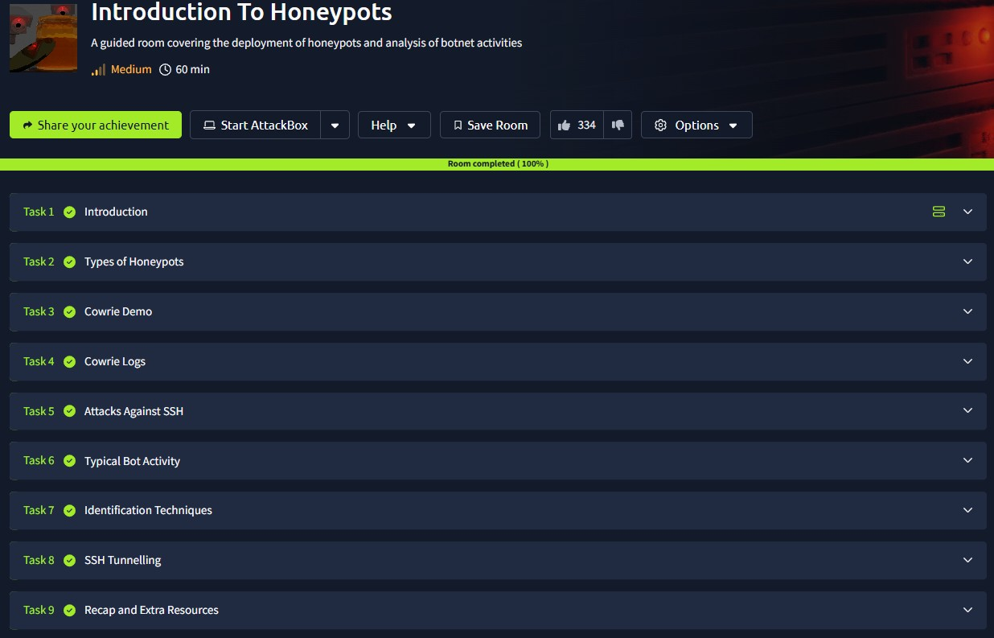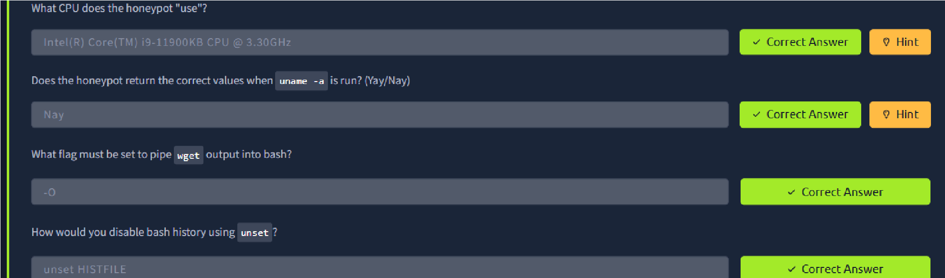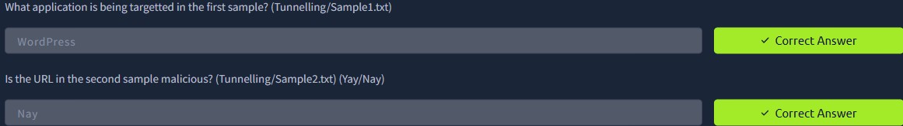

Result: Successfully set up honeypots and captured real-world botnet traffic, analyzed patterns, and identified common attack signatures and behaviors.

